Chapter 2: Smart Healthcare and IoT Technologies
(Academic and Service Provider Review)

*Vinaytosh Mishra
Associate Professor
QT & OM Area
FORE School of Management, New Delhi, INDIA
Email: vinaytosh@fsm.ac.in

Somayya Madakam
Postdoctoral Scholar
Ben Gurion University of the Negev, Beer Sheva (ISRAEL)
+ Sami Shamoon College of Engineering, Ashdod (ISRAEL)
Email: madakam@post.bgu.ac.il

2.1. Introduction

As rightly said by our ancestors, “Health is Wealth”; among all assets, health is one of the most important factors; which will be causing human survival. Therefore, maintain good health is very essential in the entire human life to survive, live happily and for a longer time. However, human life is always hazardous to many factors including manmade disasters, natural calamities, and even unexpected pandemic diseases like COVID-19. The five-letter word ‘COVID-19’ given by medical scientists to a deadly virus made the whole world chaos (Madakam and Revulagadda, 2021). From, the last months of 2019 onwards, the entire world is facing pathogenic situations irrespective of age, sex, tribe and economic status due to corona. Affected larger number across the world, patients treated in the hospitals, and even many lost their life. Hence, the international health bodies, national bureaucracies, medical practitioners, nurses, and volunteers laboured a lot round the clock, and continue working to resolve this issue. However, the coronavirus; the alias of COVID-2019 put more cripples in the minds of techies, developers, physicians, pharmacists, and even the common people who are ultimate affecters.

In this light, a huge sea of mocks working together to get rid of this pandemic situation. Hence, there an urgent need for all the technocrats, software developers, mechatronics producers to develop healthcare-related products and services by planning carefully, design properly, develop the right solution, test with six sigma quality level, and deploy and demonstrate healthcare solutions in concerned premises. That is why Smart Healthcare is becoming one of the buzzwords on everybody lips across the world. Lots of typing was already typed using laptops, desktops, tablets, smart devices, and other personal digital assistants on Smart Healthcare. Many academicians, researchers, and graduation and post-graduation level students and corporate people are doing research and publishing innovative smart healthcare manuscripts with renowned publishers like springer, sage, emerald, Taylor & Francis, Oxford, and to name a few. Not in an exaggeration, recently there was an ocean of publications in PubMed databases since COVID-2019 started and explored its characteristics, healthcare need, treatment solutions, patient care, and post-treatment mechanisms. Gigantic of literature is already poured in the form of books, book chapters, journal articles, annual reports, and white papers, etc. A study by Oueida et al., (2019) explored that Healthcare systems in the medical sector that attend to the health of an entire population highlight the need to change healthcare systems from traditional services to smart health delivery. A series of seminars, webinars, online discussions are organizing by different industries and academic institutions to make more awareness in the public regarding smart healthcare solutions using advanced technologies. The existing communication technologies are unable to fulfil the complex and dynamic need that is put on the communication networks by the diverse smart healthcare applications (Ahad, et al., 2019). An increase in world population along with elderly people is causing fast rises in healthcare costs. Technologies (e.g., Internet-of-Things, Edge-of-Things, and Cloud-of-Things) in healthcare systems are going through a transformation where health monitoring of people is possible without hospitalization (Uddin, 2019). Healthcare domain has emerged as one of the most preferred use cases of IoT and its related technologies. However, its widespread adoption is still a distant dream (Tripathi et al., 2020). This shows that there is an urgent need of developing smart health care solutions for better human life using technologies. That is why many multinational companies are mushrooming to develop smart healthcare solutions for better patient care including ESO (2004), Headspace (2010), Kyruus (2010), Wellframe (2011), and Medely (2015) among others. Moreover, so, here are the new-age innovators of the healthcare industry. Healthcare companies like CONTUS, OSP Labs, Pattem Digital Technologies, Mindbowser, HQSoftware Lab, Mobiloitte, Biz4Intellia, Amar InfoTech, Bridgera, and KORE Wireless companies are harnessing powerful technologies to create healthcare products and services that benefit patients.
2.2. Methodology
The research methodology is a systematic process in any kind of research of qualitative and quantitative. It could be experimental, survey, ethnography, focused group discussions, in-depth interview, and action research etc., the researchers need to adopt the right research methodology. The methodology plays an important role in any kind of research investigation and manuscript writing. As this book chapter is on recent and contemporary phenomena, the study generally comes under exploratory study. Moreover, this study attempted to understand the phenomena based on secondary data. Therefore, the authors fetched the data from the web of science database using the main keywords like “IoT”, “Internet of Things”, “Healthcare”, “Smart Healthcare”, and “‘Body Area Networks” to understand the phenomena in crystal clear. However, our major focus of articles is smart healthcare using IoT. Hence, the authors are limited to this phrase and sorted those articles. The documents were searched from 1-4-2021 to 31-08-2021. The articles were from different publishers like Sage, Emerald, Springer, Taylor and Francis, and Elsevier, etc. Moreover, we got more articles from the PubMed database.

2.2.1. Web of Science – Analytics

As per the Web of Science database, the total number of research manuscripts on Smart Healthcare results right from 2001 to 26/6/2021 are found 2656; among these publications, the sum of the times cited are 50644 plus average citations per item is 19.07 with an h-index is 97. The articles are taken from indexed in SCI-Expanded, SSCI, and A&HCI. Moreover, some the research manuscripts titles are (1) A Survey on Wearable Sensor-Based Systems for Health Monitoring and Prognosis (2) Wearable Sensors for Human Activity Monitoring: A Review (3) How smartphones are changing the face of mobile and participatory healthcare: an overview, with an example from eCAALYX (4) Stimulus-responsive hydrogels: Theory, modern advances, and applications (5) Smart wearable systems: Current status and future challenges (6) Unobtrusive Sensing and Wearable Devices for Health Informatics (7) Fiber-Based Generator for Wearable Electronics and Mobile Medication (8) An IoT-Aware Architecture for Smart Healthcare Systems (9) Healthcare Data Gateways: Found Healthcare Intelligence on Blockchain with Novel Privacy Risk Control (10) A Review on Recent Advances in Doppler Radar Sensors for Noncontact Healthcare Monitoring. These are few articles exploring on Smart Healthcare.

The below are research areas records as shown in Figure 1 (Tree Map) out of 2656 articles including of Computer Science (1105) - 41.604%; Engineering (1037) - 39.044%; Telecommunication (656) - 24.699%; Chemistry (341) - 12.839 %; Materials Science (294) -
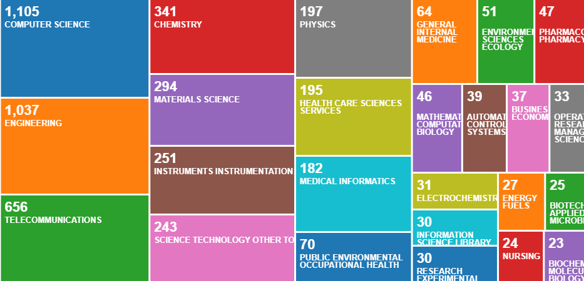
Figure 1: Research Areas - Tree Map

11.069%; Instruments Instrumentation (251) - 9.450%; Science Technology other topics (243) - 9.149%; Physics (197) - 7.417%; Health Care Sciences Services (195) - 7.342%; Medical Informatics (182) - 6.852%; Public Environmental Occupational Health (70) - 2.636%; General Internal Medicine (64) - 2.410%; Environmental Sciences Ecology (51) - 1.920%; Pharmacology Pharmacy (47) - 1.770%; Mathematical Computational Biology (46) - 1.732%; Automation Control Systems (39) - 1.468%; Business Economics (37) - 1.393%; Operations Research Management Science (33) - 1.242%; Electrochemistry (31) - 1.167%; Information Science Library Science (30) - 1.130%; Research Experimental Medicine (30) - 1.130%; Energy Fuels (27) - 1.017% and 75 research areas value(s) are not mentioned here. This tree map shows that Smart Healthcare phenomenon is interdisciplinary; hence, its applications are in many disciplines. That means this phenomenon has a sea of applications in our daily life.

The next section is going to discuss the countrywide publications on Smart Healthcare; Fig. 2 is also depicting the same on the next page. The highest publications as of today (26/6/2021) from 2001 is United States of America (USA) with 579; followed by Peoples of Republic of China with 532; then India with 359 and South Korea with 296. Moreover, England (247), Saudi Arabia (185), Australia (140), Pakistan (140), Italy (134), Canada (124), Taiwan (119) and Spain (102) is also doing a good amount of research and publications. However, countries like France (72), Germany (68), Singapore (68), Portugal (58), Brazil (55), Malaysia (55) and Egypt (51) doing better investment, conducting research and exploring Smart Healthcare solutions to the external world. However, Iran (49), Japan (48), and Sweden (45) so on countries are putting efforts on Smart Healthcare technologies for better hospital services.
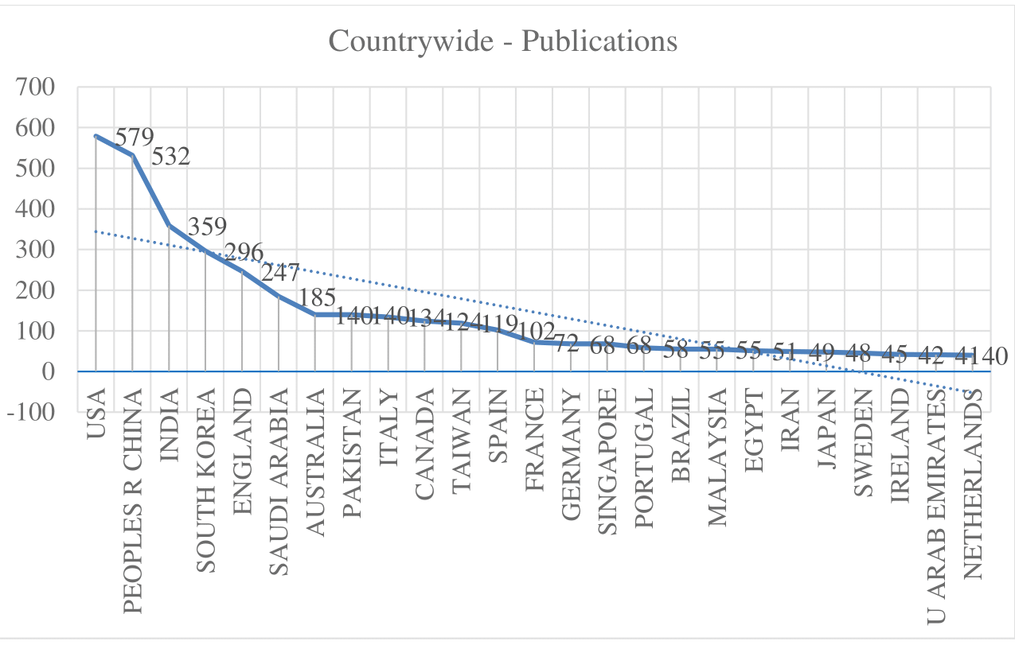
Figure 2: Countrywide – Publications

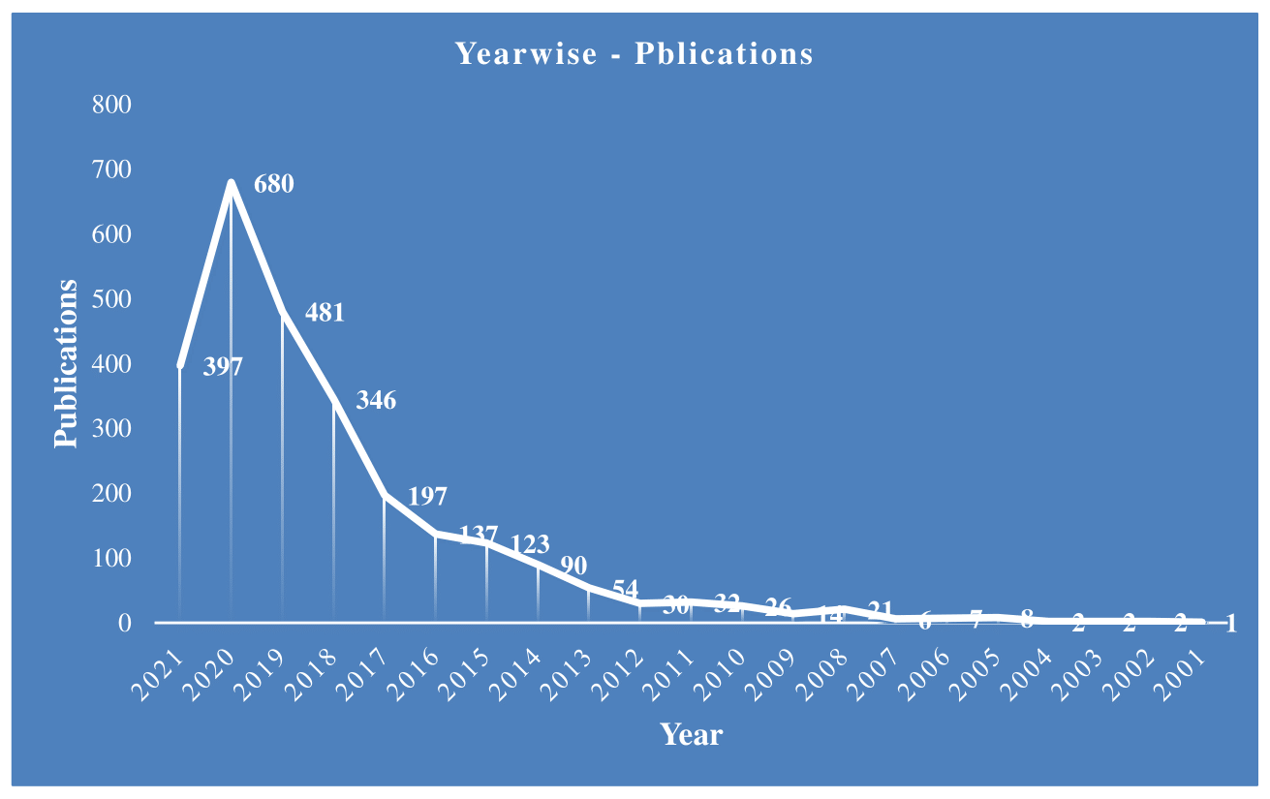
Figure 3: The Year Wise Publications
The followed section (Fig. 3) discussing the Smart Healthcare work started in the year 2001 as per the Web of Science database. Moreover, the number of publications are shown in the brackets right from the beginning is in 2001 (1); 2002 (2); 2003 (2); 2004 (2); 2005 (8); 2006 (7); 2007 (6); 2008 (21); 2009 (14); 2010 (26). This shows the growth of the publication is increasing slowly year by year. Whereas the publications are exponentially increased until today from 2011(32); 2012 (30); 2013 (54); 2014 (90); 2015 (123); 2016 (137); 2017 (197); 2018(346); 2019 (481); 2020(680) and 2021 (397). In this year 2001, still more publications yet to come on smart healthcare, as we are still in mid of the year. This kind of exponential growth in publications shows that an increase in research by academicians, and researchers in this field.

The below Figure 4 (spider) depicts the number of publications done by different authors in different journals. Here the authors only considered the authors who have done more than 10 research publications. These are KUMAR N. (29); MUHAMMAD G. (21); KIM J. (19); KUMARI S. (19); HOSSAIN M.S. (17); I X (17); CHEN M. (16); LEE S. (16); RODRIGUES JJPC (16); DAS A.K. (15); MOHANTY SP (15); YANG J. (15); ZHANG Y. (15); SOOD S.K. (14); KIM D. (13); KUMAR R. (13); PARK J.H.13); CHUNG K. (12); HASSAN M.M. (12); KUMAR S. (12); LEE J. (12); KHAN M.K. (11); RAY P.P. (11); and WANG H. (11). Moreover, many authors are not listed in this graph but contributed research papers on Smart Healthcare. The next section is sightseeing the literature, which is poured in many journals, books, annual reports, blogs etc.
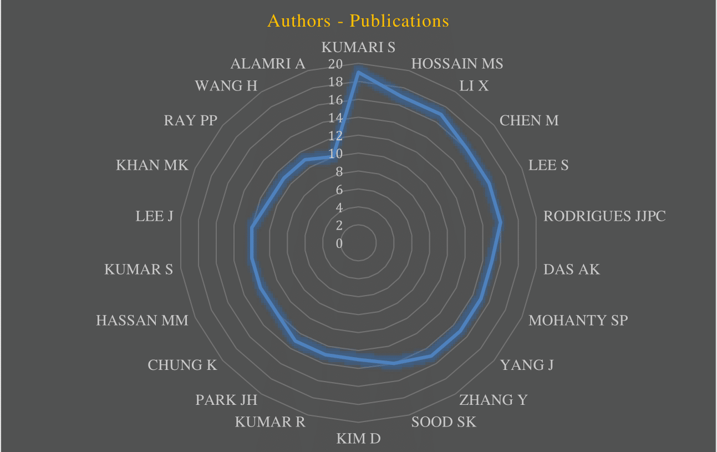
Figure 4: Authors – Publications
2.2.2 Academic Background
Man always strives for a better life in comparison to the present existing life. In this motto, he always strives to do research, and innovate different tools and technologies to enhance quality of service, which leads finally to Quality of Life. Among all, good health is an important parameter of quality of life; including sound economic conditions, good psychological state, physical security etc. as per the past academic literature. Hence, it is of paramount importance that it is taken care of for all human well-being. However, recently, we are all had very bad experience of the outbreak of Coronavirus (COVID-19) has put further strain on overburdened to human life including healthcare systems. Moreover, a rapidly aging population and the dramatic increase in the cost of in-hospital healthcare have led to the recognition of the importance of efficient healthcare systems (Nia et al., 2015). Therefore, Smart Healthcare systems being considered a solution to current challenges in healthcare (Scott et al., 2020).
A study states that blessing in disguise has been an increased adoption of digital technologies in healthcare during pandemic, especially telemedicine (Mishra, 2020). Moreover, the advances in ICTs are shaping the paradigm in healthcare and its adoption provides new opportunities, as well as discloses novel and unforeseen application scenarios (Aceto et al., 2018). A cost-effective and sustainable healthcare information system relies on the ability to collect, process, and transform healthcare data into information, knowledge, and action (Demirkan, 2013). The perceived benefit of these technologies along with ease of use are the most common factors for adoption of these technologies. While issues related to design, technical concerns, familiarity with technologies, and time are the most important factors cited in the literature (Gagnon et al., 2012). Therefore, in depth research is needed to understand the specific socio-technical factors shaping digital innovations in healthcare (Habran et al., 2018). However, now with the help of global corporates, the IT/ITeS, and other advanced manufacturing companies across globe are planning, designing, manufacturing, supplying and deploying different kind of Internet of Things (IoT) technologies and solutions in both personal as well as official process. In the last decade, there has been encouraging developments in the utilization of Internet of Things. Internet of Things-enabled solutions are spurring the advent of novel and fascinating applications in the last few years. Among others, mainly radio frequency identification (RFID), wireless sensor network (WSN), and smart mobile technologies are leading this evolutionary trend (Catarinucci et al., 2015). We have witnessed an increased use of digital technologies like mobile apps in contact tracing and continuous monitoring of the patients during the pandemic outbreak. Technologies like continuous glucose monitoring and insulin pump are being used for the last two decades but their adoption may increase as the cost is falling and people are becoming more technophile. The market for wearable technologies such as fitness watches has significantly increased in recent years. These devices can communicate with the caregiver and treatment plans can be customized. These wearable and assistive technologies are generating massive amounts of data. If we analyses this data, we can not only increase quality of care but also individualize the care provided to a patient. Need not to say, sensors will shape the future of medicine, being termed as precision medicine.
Smart Healthcare Systems being considered a solution to current challenges in healthcare (Vayena et al, 2018, Scott et al., 2020). It is defined as the use of advanced technologies to improve diagnosis of disease, treatment of patients, and improve the quality of life for the patients. The key concept of smart health includes eHealth and mHealth services, electronic record management, smart home services and intelligent and connected medical devices. The term smart health and digital health has been interchangeably used in much literature (Lupton, 2014;). Smart healthcare can promote interaction between all parties in the healthcare field,
ensure that participants get the services they need, help the parties make informed
decisions, and facilitate the rational allocation of resources (Tian, et al., 2019). However, use of smart health is not very well developed, and its potential has been little exploited. There are many reasons for the limited diffusion of these digital health technologies and knowledge, opportunities for training, ethical and privacy issues are to name a few (Gjellebæk et al.,2020).

Smart Healthcare not only means adopting new products and technologies for diagnosis and treatment, but it includes a greater exchange of information among the parties, a more active role of patients during treatment and, finally, a better management of clinical data. Smart Healthcare systems need a wide range of technology to be implemented properly (Haque et al., 2021). In the last decade, there has been encouraging developments in the utilization of Internet of Things (IoT) in healthcare. IoT can be defined as a network of devices interacting with each other via machine-to-machine (M2M) communications, enabling collection and exchange of data. These technologies enable automation in healthcare and being hailed as the driver of fourth revolution in healthcare also termed as Healthcare 4.0 (Islam et al., 2015; Yuehong et al., 2016). It is a computing process, in which each object is lashed with sensors, micro-controllers, and transceivers for enabling the communication among these devices. This communication is facilitated by suitable protocol stacks, which help these devices in interacting with each other and communicating with the users (Kodali, 2015). Medical IoT (m-IoT) aggregate, analyses and communicate synchronous medical information to the cloud, thus making it possible to collect, store, and analyze this voluminous data in various forms to get useful insights. Karjagi and Jindal (2021) in their article explain the four steps of the IoT implementation in healthcare system. According to them, the four stages of its implementation are (1) deployment of interconnected devices (2) data aggregation and pee-processing (3) storage of data in the cloud, and (4) data analysis for effective decision-making. This four-stage step is summarized in Figure 5 (next page). Thus, m-IoT enables continuous and ubiquitous communication among connected medical devices so that they can help in improving the quality of care. Each of these devices are powered by batteries and hence it is utmost important that power consumption is minimized to prolong the life of the healthcare system. Thus, IoT based medical devices are improving the quality of care with regular monitoring and reducing the cost of care with increased efficiency. Considering their usefulness, IoT- enabled medical solutions are spurring in the last few years (Catarinucci et al., 2015). Some of the major advantages of IoT in healthcare are (1) cost reduction through real time monitoring, (2) improved treatment and diagnostics, (3) proactive treatment (4) drug and equipment management, and (5) reduced errors, waste, and system costs.
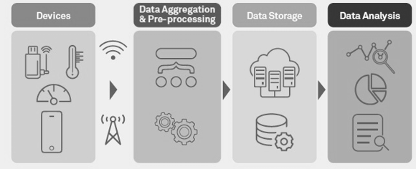
Fig. 5: The four stages of IoT solutions (Source: Authors)
Internet of Things enables data collection technologies like Wireless Body Area Networks (WBAN) and Wireless Sensor Networks (WSN) are increasingly being used for collecting, storing, and processing patient-centric data. Accurate information and real-time data sharing have helped increase the quality in emergency medical care (Edoh, 2019). Moreover, Anderson and Knickman (2001) in their research article envisaged the increased usefulness of IoT in chronic illness. As the continuous monitoring is an essential component in management of disease such as diabetes and other metabolic disorders, IoT based solutions are immensely helpful (Longva and Haddara, 2019). Internet of Things is also useful in providing information and monitoring during COVID-19 epidemic. It can be used to provide an automated and transparent treatment process to tackle the pandemic situation (Singh et al., 2020). Besides, Kumar et al. (2020) in their seminal paper highlighted the importance of IoT-based application in contact tracing to avoid spreading this infectious disease. To realize the full potential of IoT in healthcare it needs to overcome some apparent challenges including security, privacy, wear-ability, and low-power operation (Baker et al., 2017). There is a need for a Smart Healthcare System (SHS) that makes the healthcare system smarter to protect the data and maintain privacy. An SHS contains several IoT devices, sensors, and mobile nodes that collect the data from the patient's body and store it remotely (Singh & Chatterjee, 2021). I addition, there is a need for research at the intersection of healthcare, data analytics, wireless communication, embedded systems, and information security. With the rapid change in the landscape in healthcare, it is imperative to review the recent applications of IoT in healthcare. Smart healthcare can reduce the need of visit to physicians for regular health checkups. In Smart healthcare, wearable sensors generate enormous data, which need to be stored securely as well processed for knowledge extraction (Saif et al., 2021).

2.3 Cases

This section discusses the use cases for use of technologies in smart healthcare.

2.3.1. Case 1: Watson Health

IBM (International Business Machines) Watson Health is a division of IBM, having headquartered in New York, USA. It enables organizations to solve important challenges for stakeholders by offering a data-driven solution and real results. According to information available on their website, they use the following smart technologies for solving problems of healthcare.
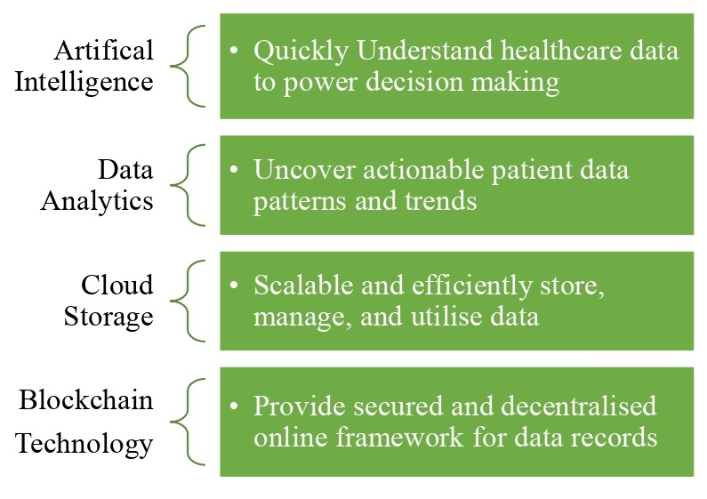
Fig 6: Watson Health’s Smart Technologies (Source: Authors’)

They claim that their healthcare consulting clients have an average Return on Investment (RoI) of 10:1. Watson Health’s Natural Language Processing (NLP), hypothesis generation, and evidence-based learning capabilities are being evaluated for their contribution to clinical decision support systems. In the year 2011, IBM entered in partnership with Cleveland Clinic to utilize Watson Health for augmenting medical professional’s expertise in treating patients. Recently, IBM and Manipal Hospital in India announced the use of Watson Health for the oncology department. It is believed that it will be carrying the knowledge base of 1000 cancer specialists and it will be a game-changer in cancer treatment. Watson Health has other non-clinical use cases compensation management, inventory management, preventive maintenance, theft detection, and fraud detection to name a few. Moreover, Watson Health can help in delivering efficient healthcare and significantly improved quality of care.

2.3.2.Case 2: Verily

Google recently renamed its company Google Lifesciences to Verily. Verily is Google’s ambitious attempt foray into the trillions dollar healthcare industry. Verily marks Alphabet’s official entry into the field of smart healthcare using the Internet of Things to gain insight into health. The healthcare industry is facing the dual challenge of cost and quality worldwide. This tech giant aims to solve these perennial problems with smart healthcare technologies. The firm will look to collect data from sensors, fitness bands, smartwatches equipped with monitors, and other IoT devices and analyze this data using Google’s AI capabilities to detect the pattern in the data, which could lead to a proactive treatment or individualized care. The company has already done its “Baseline Study” to find out what constitutes a healthy human being to look for signs for deviation from this state. The company has developed smart contact lenses that looked for signs of Glaucoma. Verily, in collaboration with Vanderbilt University Medical Center and the Broad Institute of MIT (Massachusetts Institute of Technology) and Harvard, built the data research and support center to organize the multi-modal and complex data sets collected. Verily in association with American Heart Association (AHA) and AstraZeneca, has come up with a research initiative “One Brave Idea”. This initiative aims to uncover new approaches to preventing and treating Coronary Heart Disease (CHD). They also have notable research initiatives like Parkinson's Progressive Markers Initiative, Immune Profiler, and analysis of risk factors of Multiple Sclerosis (MS). Google and Verily have developed a Machine-Learning (ML) algorithm to make it easier to screen for diseases such as Diabetes Retinopathy (DR) and Diabetic Macular Edema (DME). The company conducted a clinical research program in association with Aravind Eye Hospital in Madurai, with a focus on India, a country being termed as the diabetes capital of the world (Kasumi and Virmani, 2021)
. The ML based process for DR, and DME screening is shown below in Figure 7.

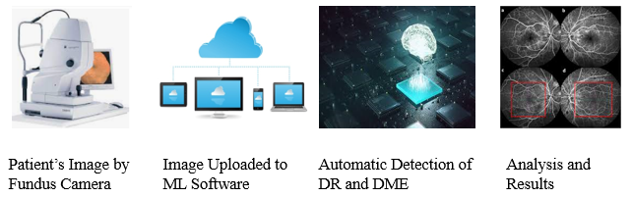

Fig 7: Steps for Machine Learning Screening Works at the Hospital in Madurai (Source: Authors)

2.3.3. Case 3: Intel Healthcare & Life Sciences

Smart Healthcare can help to enrich the life of every person on earth. Technologies like Artificial Intelligence (AI), robotics, and the Internet of Things are making healthcare and life sciences more connected, personalized, and intelligent. We know that M/s. Intel is another tech giant that has envisioned the use of technologies in making healthcare smarter. They have invested profoundly in their healthcare and life sciences division. Their technologies have the application from medical imaging to disinfecting the hospital premises. They have collaborated with the Broad Institute of MIT and Harvard to provide the impetus for their genomics research. The technological advancement in recent years has made it possible to practice precision medicine. With the help of Intel’s healthcare technologies, clinicians use a combination of genomic data, health records, lab tests, and other patient data to customize their care. In a nutshell, Intel healthcare technologies create efficiencies that enable providers to focus more on the human side of care delivery. Some of the use cases of Intel’s healthcare technologies are listed in Figure 8 Below:
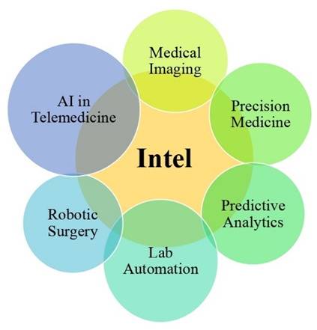
Fig. 8: Use Cases of IMB Healthcare Technologies (Source: Authors’)

2.3.4. Case 4: Lumiata

Intel’s Venture Capital Arm, Intel Capital has heavily invested in a smart healthcare start-up named Lumiata. It is reshaping the healthcare enterprise at scale through the application of AI, bringing predictive power within the reach of business leaders and data science teams. Its data science productivity tools and pre-trained models comprise a scalable platform, purpose-built for healthcare, and generated from more than 120 million patient records, in-depth clinical knowledge, and Lumiata's proprietary disease codes. The platform offered by the company enables a user to run their customized predictive model for various use cases. The company offer services and consulting in clinical as well as allied healthcare area. Lumiata offers services in various verticals such as actuarial and underwriting, care and disease management, COVID planning and management, data management, payment integrity, and telemedicine. These all services are deployed and monitored through a single solution. The services offered by Lumiata are summarised in Figure 9 (next page). i.e. (1) AI modelling (Using supervised, un-supervised, semi-supervised and reinforcement techniques) (2) Data management (Huge amount of healthcare data relating to hospital infrastructure, human resource, pharmaceutical, in and out patient data and operations, treatments and billing etc.) (3) Healthcare analytics (Patient data collection, data cleaning, feature selection, training and testing and generating model) (4) Predictive modelling (Predicting the output results and their associated costs in the future for better treatment) and (5) Machine Learning–Life Cycle Management (Technological Management right from the Hospital Information System designing, developing and testing, deploying in hospital using advanced technologies along with maintenance)
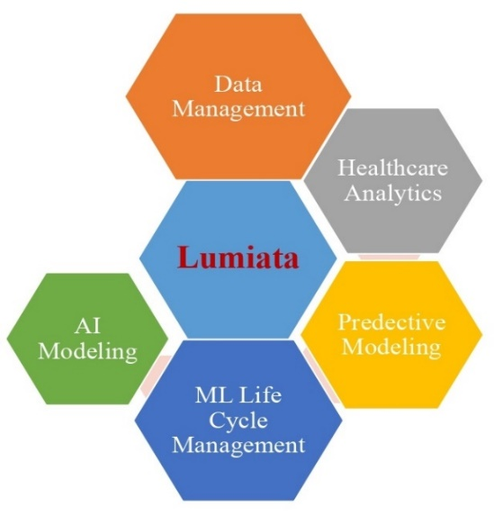

Fig 9. Service Offerings of Lumiata (Source: Authors’)
2.5. Discussion
Healthcare Systems are facing unprecedented challenges such as the outbreak of infectious diseases, increased prevalence of chronic disease, shortage of doctors, and clinicians, lack of timely medicines, aging population, and rising cost, etc. Hence, Healthcare Systems worldwide should focus on the triple aim of better-individualized care, improved population health, and lower healthcare cost. That means addressing these issues requires the use of smart health technologies that make healthcare more intelligent, distributed, and personalized. These advanced technologies like IoT smart devices, Edge (Fog) computing, Artificial Intelligence, and computer vision are shaping the landscape of the future of healthcare. Moreover, the applied technologies like Medical Imaging (MI), bedside telemetry, and Natural Language Processing (NLP) are augmenting the work of clinicians and hence enabling them to focus more on the human side of care. Among all, the Internet of Things technologies has been immensely used in healthcare. Internet of Things-enabled devices have made remote monitoring of patients possible and have many applications in chronic disease management and providing geriatric care. A closed-loop system having a Continuous Glucose Monitoring System (CGMS) and Insulin Pump can act as an artificial pancreas for a diabetes patient having insulin resistance and are a boon for Type-2 Diabetes Mellitus patients. IoT-enabled devices can generate an alarm in case of hypoglycaemia and save the life of a diabetic patient. IoT-enabled devices can be used for performance monitoring of critical medical equipment and raise the alarm when preventive maintenance is required. Recently blue tooth-enabled proximity tracking apps were found very helpful in contract tracing during the recent outbreak of COVID-19 disease. Besides, IoT also has other non-clinical applications as hospital environment monitoring through Closed Circuit Tele Vision (CCTV)/ Internet Protocol (IP) Camera, inventory management, and theft detection round the clock.

IBM, Google, Intel, Microsoft, and many more tech giants have realized the potential of smart healthcare and working on future technologies to achieve these issues resolving challenges faced by healthcare. Venture capitalists like Intel Capital have envisaged the growth of smart healthcare in near future and invested in smart healthcare start-ups such as Lumiata. Another area where technology companies are seeing potential is telemedicine. The COVID-19 pandemic has increased the acceptance of telemedicine services. Telemedicine coupled haptics, body sensors, and new protocols can bring telehealth one echelon up in near future. However, it is all not rosy in the saga of smart healthcare technologies deployment in hospital premises to implement Smart Healthcare such as Hospital Information Systems (HIS) in a full pledge. On the otherwise, privacy and security are some of the concerns in the use of connected healthcare technologies relating to patient’s confidential data including demographic and chronic disease physiognomies. Hence, the HIS should install various malware and fraud detection software including antivirus and firewalls from different known companies like Symantec, Dr. Solomon, Trend Micro, Kesper Sky, and so on. In addition, the government should come up with standard processes and regulations; cybersecurity to ally the apprehension about these concerns. However, now the European Union started framing General Data Protection Regulation (GDPR) for securing citizen data. If managed appropriately smart healthcare has the sky as a limit. This will finally lead to Quality of Life.
2.6. Conclusion
This book chapter discussed smart healthcare phenomena using advanced technologies. We know that healthcare deals with patients, diseases, medicines, doctors, nurses, treatments and its’ associated health information systems. The current healthcare systems are not self-sufficient and not fully deployed with advanced technologies to bring operational efficiency in the entire medicinal treatments. Hence, Information Technology (IT/ITeS) and other tech-giant companies in them seem less research and development (R&D); innovated, innovating and will invent more advanced technologies for round the clock assistance in hospitals for better patient care. In that effort, the new technologies come out in the name of the “Internet of Things”. Internet of Things is new technologies that are used to connect to physical things or objects using intelligent embedded technologies to identify, automate, monitor and control. There is an ocean of applications of the Internet of Things that we are experiencing in our daily life including the healthcare sector. Sensors, actuators, Wi-Fi (Wireless Fidelity), Bluetooth, ZigBee, microcontrollers [raspberry pi and Arduino], Radio Frequency Identification (RFID): [active, passive and semi passive], Barcodes, Electronic Product Code (EPC), Quick Response (QR) codes, web 3.0, Enterprise Resource Planning (ERP), Geographic Information Systems [Arc GIS), cloud storage, and Geographic Position Systems (GPS) are some of the health information technologies using in hospitals. The Healthcare sector is the first to use IoT technologies in a bigger way including x-ray, CT scanning, stethoscope and other healthcare devices for check-up body parameters. Internet of Things heavily used for monitoring of the remote patient, heart rate, glucose, hand hygiene, depression and mood. Moreover, Parkinson’s disease monitoring connected inhalers and ingestible sensors to name some more IoT applications in healthcare. In addition to monitoring patients' health conditions, the IoT devices are very useful in various hospitals fields including tagging with sensors, GIS and GPS for tracking the real-time location of medical equipment like wheelchairs, defibrillators, nebulizers, oxygen pumps and other monitoring equipment. Besides, the Body Area Networks (BAN) also one of the upcoming healthcare technology in which smart healthcare devices will be embedded into the human body based on the functionality of BAN to sense human body parameters like sweating, temperature and logs of your medical data will share to the doctors do the analysis. The increasing use of wireless networks and the constant miniaturization of electrical devices has empowered the development of Wireless Body Area Networks (WBANs) (Latré, et al., 2011). There are many smarter care solutions are available in the market like home care, old age, antenatal care, and chronic patients. Hence, the best way to get rid of pandemic situations like corona-wave 1 is to adopt the Internet of Things in all the fields of the healthcare sector so that Quality of Services will be provided 24/7/ for Quality of Life.
This book chapter also explored the existing academic literature of smart healthcare and IoT basic definitions, connotes, and technologies. So finally, we understood that smart healthcare is nothing but the provision of health-related services provided by IoT devices and its sister technologies for patient care in a better way. Web of Science analysis on academic literature giving some statistics on author wise, countrywide, and year wise publications on these phenomena. Moreover, the case industry crystal clear explanations of smart healthcare on different industries is clear-cut adoption of smart healthcare across the globe. From this book chapter we can also understand that it is the need of the hour, we need to plan, design, develop, and deploy IoT healthcare technologies in all healthcare fields in a bigger way for smart healthcare systems to provide Quality of Life to all human beings. Let us welcome smart healthcare in a bigger way in our daily life to face any kind of pandemic situations in the future. Therefore, simply understand the principle:

“Smart Healthcare = Healthcare + Internet of Things”.
IoT enabled healthcare has many advantages but it comes with its own challenges. The biggest challenge associated with smart healthcare is security and privacy. IoT devices can pose a threat to users’ security and privacy. The second daunting challenge is inter-realm authentication and interoperability issues. In addition to this, there is shortage of skilled human resource needed for managing smart healthcare operations. If these challenges are addressed satisfactorily, smart healthcare can solve many perennial problems associate with traditional healthcare.
Reference

Aceto, G., Persico, V. and Pescapé, A., 2018. The role of Information and Communication Technologies in healthcare: taxonomies, perspectives, and challenges. Journal of Network and Computer Applications, 107, pp.125-154.
Ahad, A., Tahir, M. and Yau, K.L.A., 2019. 5G-based smart healthcare network: architecture, taxonomy, challenges and future research directions. IEEE access, 7, pp.100747-100762.
Ahad, A., Tahir, M., & Yau, K. L. A., 2019. 5G-based smart healthcare network: architecture, taxonomy, challenges and future research directions. IEEE access, 7, pp.100747-100762.
Anderson, G. and Knickman, J.R., 2001. Changing the chronic care system to meet people’s needs. Health Affairs, 20(6), pp.146-160.
Baker, S.B., Xiang, W. and Atkinson, I., 2017. Internet of things for smart healthcare: Technologies, challenges, and opportunities. IEEE Access, 5, pp.26521-26544.
Catarinucci, L., De Donno, D., Mainetti, L., Palano, L., Patrono, L., Stefanizzi, M.L. and Tarricone, L., 2015. An IoT-aware architecture for smart healthcare systems. IEEE internet of things journal, 2(6), pp.515-526.
Demirkan, H., 2013. A smart healthcare systems framework. It Professional, 15(5), pp.38-45.
Edoh, T., 2019. Internet of things in emergency medical care and services. In Medical Internet of Things (m-IoT)-Enabling Technologies and Emerging Applications. IntechOpen.
Gagnon, M.P., Desmartis, M., Labrecque, M., Car, J., Pagliari, C., Pluye, P., Frémont, P., Gagnon, J., Tremblay, N. and Légaré, F., 2012. Systematic review of factors influencing the adoption of information and communication technologies by healthcare professionals. Journal of medical systems, 36(1), pp.241-277.
Gjellebæk, C., Svensson, A., Bjørkquist, C., Fladeby, N. and Grundén, K., 2020. Management challenges for future digitalization of healthcare services. Futures, 124, p.102636.
Habran, E., Saulpic, O. and Zarlowski, P., 2018. Digitalisation in healthcare: An analysis of projects proposed by practitioners. British Journal of Healthcare Management, 24(3), pp.150-155.
Haque, A.B., Muniat, A., Ullah, P.R. and Mushsharat, S., 2021, February. An Automated Approach towards Smart Healthcare with Blockchain and Smart Contracts. In 2021 International Conference on Computing, Communication, and Intelligent Systems (ICCCIS) (pp. 250-255). IEEE.
Islam, S.R., Kwak, D., Kabir, M.H., Hossain, M. and Kwak, K.S., 2015. The internet of things for health care: a comprehensive survey. IEEE access, 3, pp.678-708.
Karjagi R and Jindal M, What IoT can do for healthcare? Assessed on June 4, 2021
https://www.wipro.com/business-process/what-can-iot-do-for-healthcare-/
Kasumi Widner and Sunny Virmani, New milestones in helping prevent eye disease with Verily, Assessed on June 4, 2021, https://www.blog.google/technology/health/new-milestones-helping-prevent-eye-disease-verily/)
Kodali, R.K., Swamy, G. and Lakshmi, B., 2015, December. An implementation of IoT for healthcare. In 2015 IEEE Recent Advances in Intelligent Computational Systems (RAICS) (pp. 411-416). IEEE.
Latré, B., Braem, B., Moerman, I., Blondia, C. and Demeester, P., 2011. A survey on wireless body area networks. Wireless networks, 17(1), pp.1-18.
Longva, A.M. and Haddara, M., 2019. How can iot improve the life-quality of diabetes patients? In MATEC Web of Conferences (Vol. 292, p. 03016). EDP Sciences.
Lupton, D., 2014. Critical perspectives on digital health technologies. Sociology compass, 8(12), pp.1344-1359.
Madakam S., Revulagadda R.K., 2021. Software Engineering Analytics—The Need of Post COVID-19 Business: An Academic Review. In: Patnaik S., Tajeddini K., Jain V. (eds) Computational Management. Modeling and Optimization in Science and Technologies, vol 18. Springer, Cham. https://doi.org/10.1007/978-3-030-72929-5_11
Mishra, V., 2020. Factors affecting the adoption of telemedicine during COVID-19. Indian Journal of Public Health, 64(6), p.234.
Nia, A.M., Sur-Kolay, S., Raghunathan, A. and Jha, N.K., 2015. Physiological information leakage: A new frontier in health information security. IEEE Transactions on Emerging Topics in Computing, 4(3), pp.321-334.
Oueida, S., Aloqaily, M. and Ionescu, S., 2019. A smart healthcare reward model for resource allocation in smart city. Multimedia tools and applications, 78(17), pp.24573-24594.
Saif, S., Datta, D., Saha, A., Biswas, S. and Chowdhury, C., 2021. Data Science and AI in IoT Based Smart Healthcare: Issues, Challenges and Case Study. In Enabling AI Applications in Data Science (pp. 415-439). Springer, Cham.
Scott, B.K., Miller, G.T., Fonda, S.J., Yeaw, R.E., Gaudaen, J.C., Pavliscsak, H.H., Quinn, M.T. and Pamplin, J.C., 2020. Advanced digital health technologies for COVID-19 and future emergencies. Telemedicine and e-Health, 26(10), pp.1226-1233.
Singh, A. and Chatterjee, K., 2021. Securing Smart Healthcare System with Edge Computing. Computers & Security, p.102353.
Singh, R.P., Javaid, M., Haleem, A. and Suman, R., 2020. Internet of things (IoT) applications to fight against COVID-19 pandemic. Diabetes & Metabolic Syndrome: Clinical Research & Reviews, 14(4), pp.521-524.
Tian, S., Yang, W., Le Grange, J.M., Wang, P., Huang, W. and Ye, Z., 2019. Smart healthcare: making medical care more intelligent. Global Health Journal, 3(3), pp.62-65.
Tripathi, G., Ahad, M. A., & Paiva, S. (2020, March). S2HS-A Blockchain based approach for smart healthcare system. In Healthcare (Vol. 8, No. 1, p. 100391). Elsevier.
Uddin, M. Z.,2019. A wearable sensor-based activity prediction system to facilitate edge computing in smart healthcare system. Journal of Parallel and Distributed Computing, 123, pp.46-53.
Yuehong, Y.I.N., Zeng, Y., Chen, X. and Fan, Y., 2016. The internet of things in healthcare: An overview. Journal of Industrial Information Integration, 1, pp.3-13.

